13. Implementing database security measures (e.g. user authentication, access control).

use school;
show databases;

create table employee(
id int auto_increment primary key,
name varchar(100),
email varchar(100),
salary decimal(10,2)
);

--2. Create Users (Authentication)
create user if not exists 'readonly_user'@'localhost'
identified by 'gauri@12';

--Read/Write User
create user if not exists 'write_user'@'localhost'
identified by 'bhavana@22';

--Admin User(for this DB only)
create user if not exists 'db_admins'@'localhost'
identified by 'admin@123';

--3. Grant Privileges (Access Control)

--Grant Select only to readonly_user
grant select on secure_db.* to'readonly_user'@'localhost';

--Grant SELECT,INSERT,UPDATE,DELETE to write_user
grant select,insert,update,delete on secure_db.* to'write_user'@'localhost';

--Grant ALL privileges (but only for this DB) to db_admin
grant all privileges on secure_db.* to'db_admins'@'localhost';

--Apply privileges
flush privileges;

--4. Check privileges for each user
-- Check all users
select user,host from mysql.user;

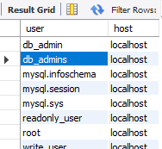

--Check privileges for each user
show grants for 'readonly_user'@'localhost';

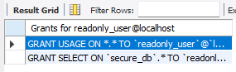

show grants for 'write_user'@'localhost';

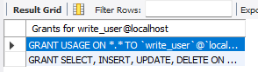

show grants for 'db_admin'@'localhost';
